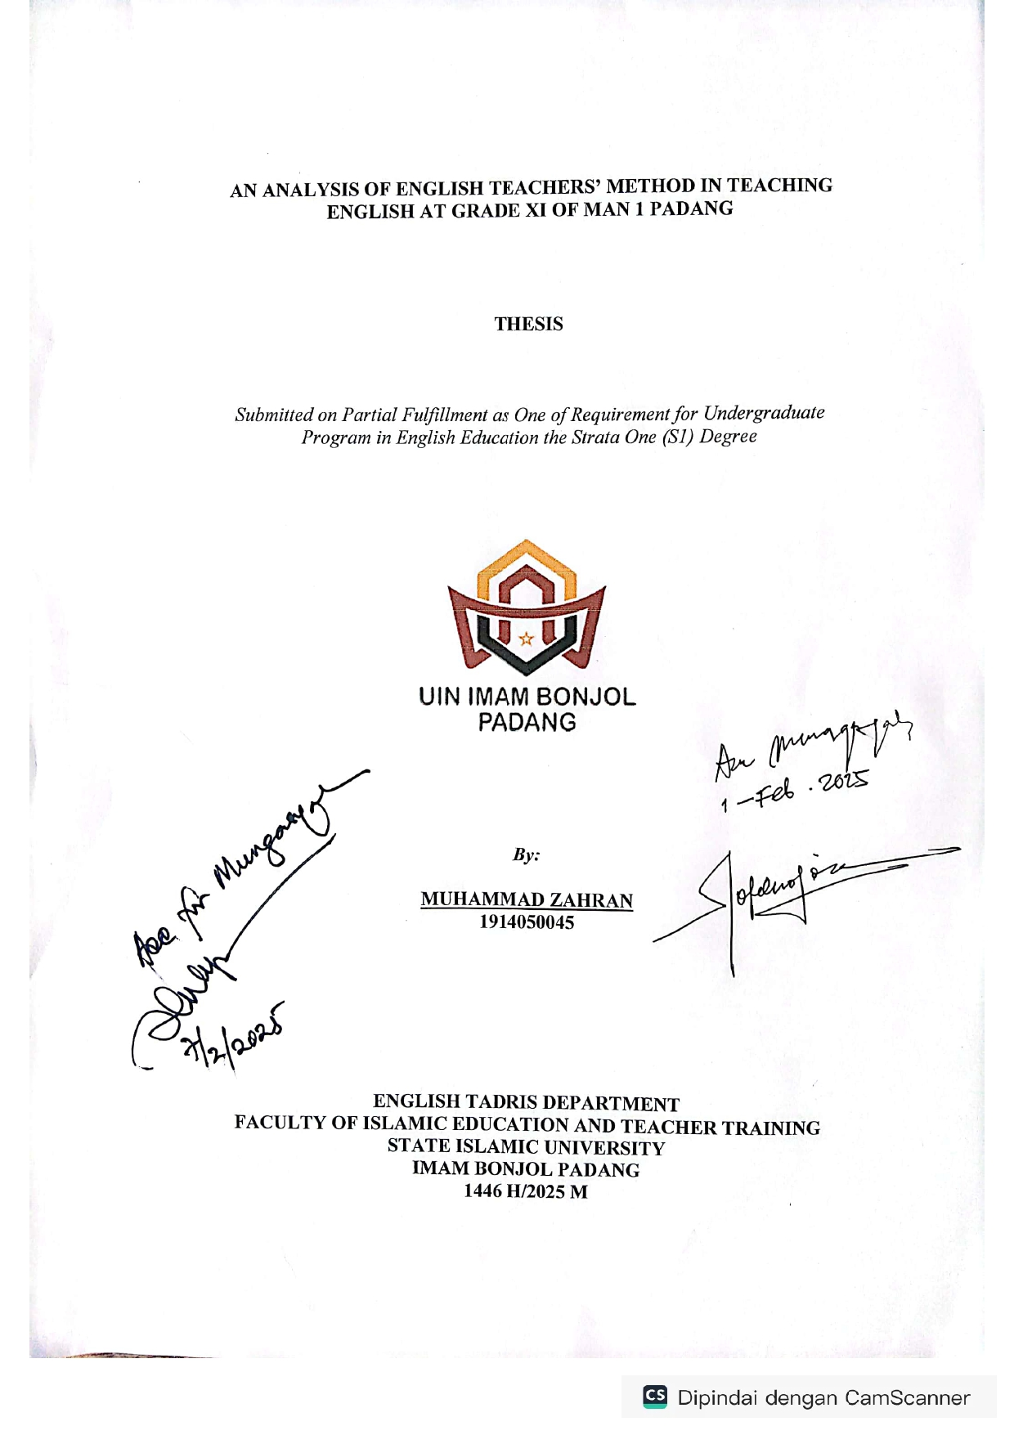

AN ANALYSIS OF ENGLISH TEACHERS’ METHOD IN TEACHING ENGLISH AT GRADE XI OF MAN 1 PADANG

THESIS

Submitted on Partial Fulfillment as One of Requirement for Undergraduate Program in English Education the Strata One (S1) Degree



By:

MUHAMMAD ZAHRAN 1914050045

ENGLISH TADRIS DEPARTMENT
FACULTY OF ISLAMIC EDUCATION AND TEACHER TRAINING STATE ISLAMIC UNIVERSITY
IMAM BONJOL PADANG 1446 H/2025

DECLARATION

I hereby state that thesis entitled An Analysis of English Teachers’ Method in Teaching English at Grade XI Of MAN 1 Padang, this thesis is true masterpiece of myself. I fully aware that I have quoted some statements and ideas from various sources and they are properly acknowledged in my thesis. I do not copy or quote with the way that it against from the scientific ethic that occur in the scientific society. From the statement above, I am ready to accept any judgement if it found there is scientific ethic contrary in this thesis or there is claim from another side toward the original word

Padang, February 2025 Researcher
Muhammad Zahran 1914050045

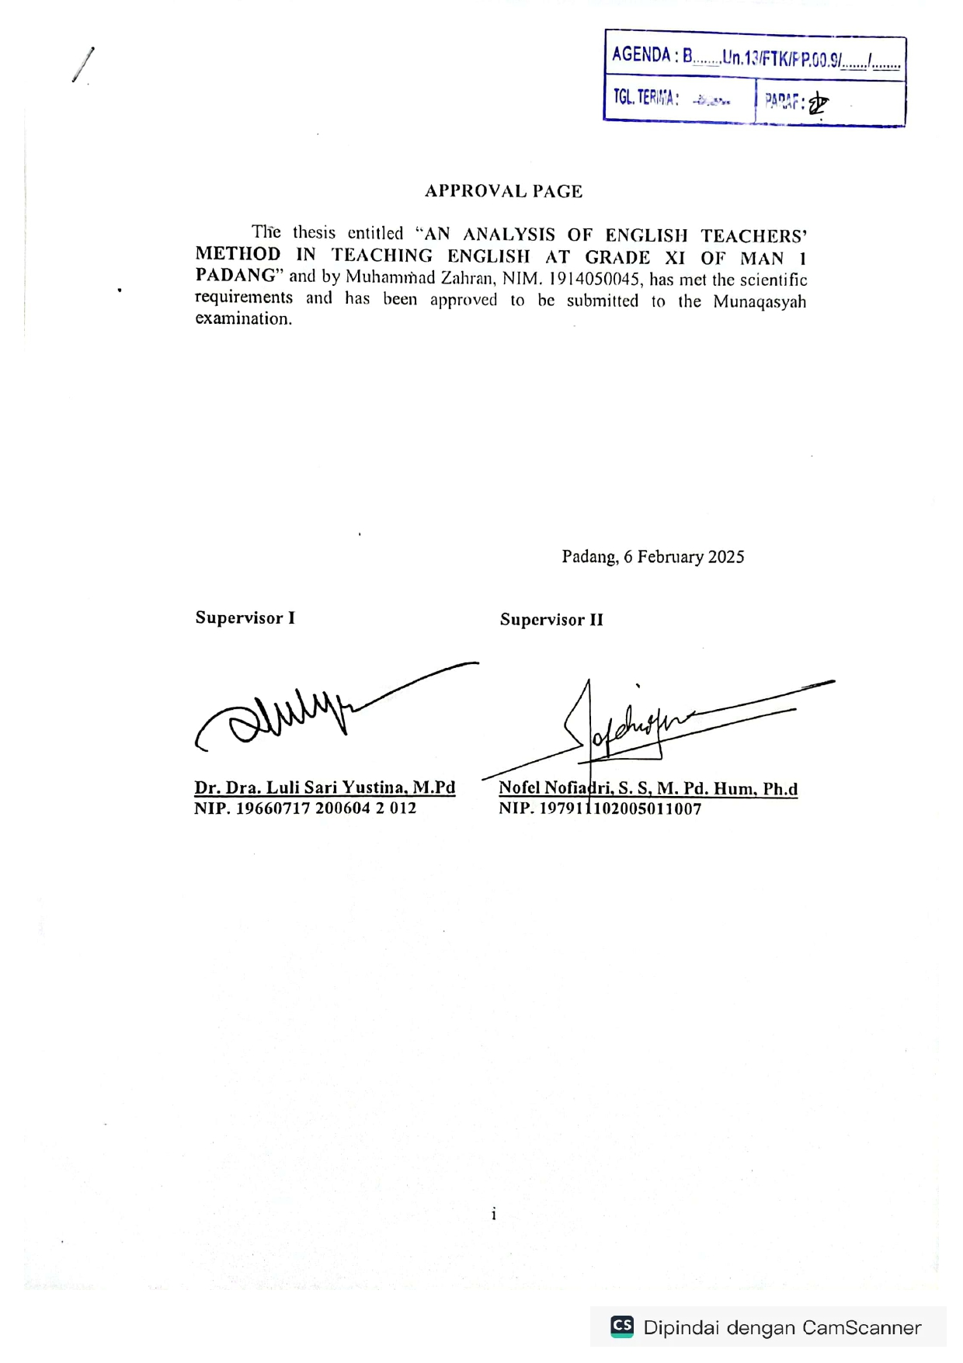

APPROVAL PAGE

AN ANALYSIS OF ENGLISH TEACHERS’ METHOD IN TEACHING ENGLISH AT GRADE XI OF MAN 1 PADANG

By:

MUHAMMAD ZAHRAN 1914050045

This thesis was approved for examination

 | Padang, February 2025
First Supervisor | Second Supervisor
Dr. Hj. Luli Sari Yustina, M.Pd NIP. 19660717 200604 2 012 | Nofel Nofiadri, S. S, M. Pd. Hum, Ph.d NIP. 197911102005011007

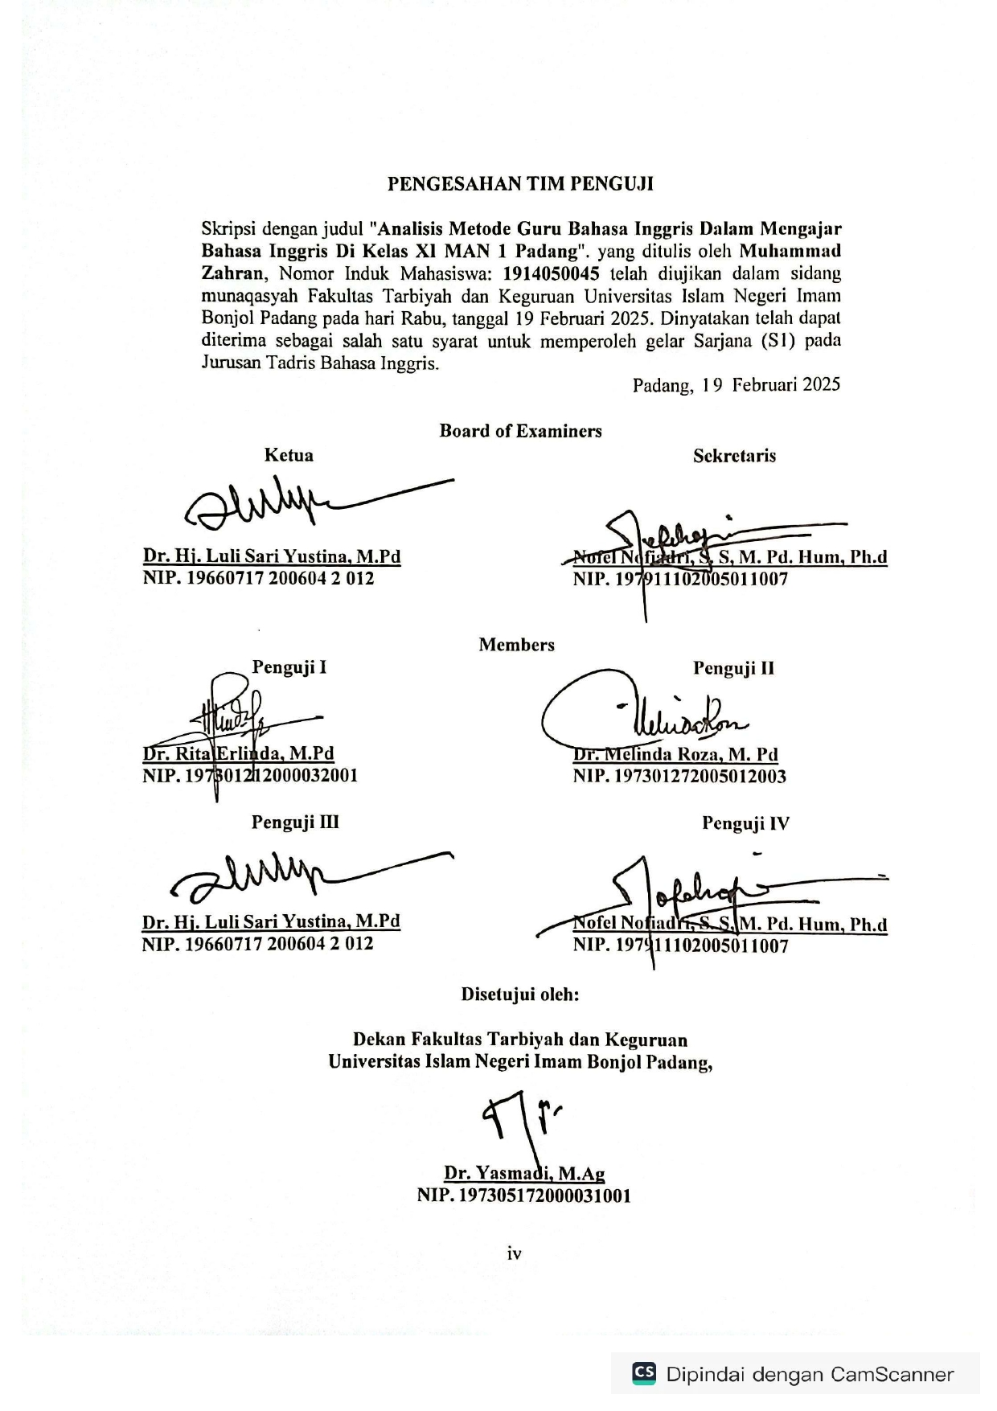

THESIS ACCEPTANCE

This thesis entitles “An Analysis of English Teachers’ Method in Teaching English at Grade XI Of MAN 1 Padang”. Written by Muhammad Zahran, Student Register Number: 1914050045 has been examined by Board of Examination members in the Faculty of Islamic Education and Teacher Training State Islamic University Imam Bonjol Padang, on Wednesday, February 19th 2025. Therefore, it has accepted for part of Sarjana (S1) in English Tadris Department.
Padang, February 19th 2025

Board of Examiners
Chairperson  Dr. Hj. Luli Sari Yustina, M.Pd NIP. 19660717 200604 2 012 | Secretary  Nofel Nofiadri, S. S, M. Pd. Hum, Ph.d NIP. 197911102005011007
Members
Examiner I  Dr. Rita Erlinda, M.Pd NIP. 197301212000032001 | Examiner II  Dr. Melinda Roza, M. Pd NIP. 197301272005012003
Examiner III  Dr. Hj. Luli Sari Yustina, M.Pd NIP. 19660717 200604 2 012 | Examiner IV  Nofel Nofiadri, S. S, M. Pd. Hum, Ph.d NIP. 197911102005011007

Approved by

Dean of Faculty of Islamic Education and Teacher Training State Islamic University Imam Bonjol Padang,

Prof. Dr. Yasmadi, M.Ag NIP. 19730517200003100

PENGESAHAN TIM PENGUJI

Skripsi dengan judul "Analisis Metode Guru Bahasa Inggris Dalam Mengajar Bahasa Inggris Di Kelas XI MAN 1 Padang". yang ditulis oleh Muhammad Zahran, Nomor Induk Mahasiswa: 1914050045 telah diujikan dalam sidang munaqasyah Fakultas Tarbiyah dan Keguruan Universitas Islam Negeri Imam Bonjol Padang pada hari Rabu, tanggal 19 Februari 2025. Dinyatakan telah dapat diterima sebagai salah satu syarat untuk memperoleh gelar Sarjana (S1) pada Jurusan Tadris Bahasa Inggris.
Padang, 19 Februari 2025

Board of Examiners
Ketua  Dr. Hj. Luli Sari Yustina, M.Pd NIP. 19660717 200604 2 012 | Sekretaris  Nofel Nofiadri, S. S, M. Pd. Hum, Ph.d NIP. 197911102005011007
Members
Penguji I  Dr. Rita Erlinda, M.Pd NIP. 197301212000032001 | Penguji II  Dr. Melinda Roza, M. Pd NIP. 197301272005012003
Penguji III  Dr. Hj. Luli Sari Yustina, M.Pd NIP. 19660717 200604 2 012 | Penguji IV  Nofel Nofiadri, S. S, M. Pd. Hum, Ph.d NIP. 197911102005011007

Disetujui oleh:

Dekan Fakultas Tarbiyah dan Keguruan Universitas Islam Negeri Imam Bonjol Padang,

Prof. Dr. Yasmadi, M.Ag

ABTRACT

Muhammad Zahran, 2025. An Analysis Of English Teachers’ Method In Teaching
English At Grade XI Of MAN 1 Padang

This study aimed to find out the teaching methods used by English teachers at Grade 11 MAN 1 PADANG. problems faced by the teacher in applying teaching methods in English. There are still many students who have low motivation the learning process. It seems that the students just make a little progress and learn English just to pass the exam.
The writer used descriptive-qualitative with a case study approach. The subjects were the English teachers the writer chose English teacher MAN 1 PADANG. In collecting the data observations were used. English teacher as a subject of the research who was a qualified and certified teacher, humorist, and had a lot of teaching experience. The technique of collecting data in descriptive has some varieties of techniques including interviews, observation, questioner, action research, focus meetings,and analysis of diaries and other personal texts. to analyze the data, as follows; data collection, data reduction, data display and conclusion.
The finding showed the implementation of methods used by teachers in teaching English, It was found six methods were used, namely, Question Answer Method, Role Play, Direct Method, Grammar-Translation Method, Discussion Method, and Communicative Teaching Method. Based on result, it can be concluded that the lecture method is a more appropriate method to be applied in the classroom because it helps the students to understand the language easily. Lecture allows teachers to use both their mother tongue and target language. Mother tongue was used to explain the lesson so that the students would be more assured and not be confused in learning the target language. For English teachers, it is acceptable to make variations in teaching English. The teachers should prepare and give various activities to the students because they quickly change their mood in the following activities. English teachers can use several methods or strategies, techniques, and media to make the teaching and learning process more effective and fun. Considering the student’s characteristic that easily get bored, it is also needed various teaching aids. It will be much easier and more exciting for students if you make full use of things and objects. With the method that is used by the teacher, the students hope the students more understand and enjoy his lesson.
Keywords: Teaching, Teaching method, English teacher

ABSTRAK

Muhammad Zahran, 2025. Analisis Metode Guru Bahasa Inggris Dalam Mengajar
Bahasa Inggris Di Kelas XI MAN 1 Padang
Penelitian ini bertujuan untuk mengetahui metode pengajaran yang digunakan oleh guru bahasa Inggris di kelas 11 MAN 1 PADANG. masalah yang dihadapi oleh guru dalam menerapkan metode pengajaran dalam bahasa Inggris. Masih banyak siswa yang memiliki motivasi yang rendah dalam proses pembelajaran. Tampaknya siswa hanya membuat sedikit kemajuan dan belajar bahasa Inggris hanya untuk lulus ujian.
Penulis menggunakan deskriptif-kualitatif dengan pendekatan studi kasus. Subjek penelitian ini adalah guru bahasa Inggris, penulis memilih guru bahasa Inggris MAN 1 PADANG. Dalam mengumpulkan data digunakan observasi. Guru bahasa Inggris sebagai subjek penelitian yang merupakan guru yang berkualitas dan bersertifikat, humoris, dan memiliki banyak pengalaman mengajar. Teknik pengumpulan data dalam deskriptif memiliki beberapa jenis teknik termasuk wawancara, observasi, questioner, penelitian tindakan, pertemuan terfokus, dan analisis buku harian dan teks-teks pribadi lainnya. untuk menganalisis data, sebagai berikut; pengumpulan data, reduksi data, display data dan kesimpulan.
Hasil penelitian menunjukkan implementasi metode yang digunakan oleh guru dalam mengajar bahasa Inggris, ditemukan enam metode yang digunakan, yaitu, Metode Tanya Jawab, Bermain Peran, Metode Langsung, Metode Tata Bahasa-Terjemahan, Metode Diskusi, dan Metode Pengajaran Komunikatif. Berdasarkan hasil penelitian, dapat disimpulkan bahwa metode ceramah adalah metode yang lebih tepat untuk diterapkan di kelas karena metode ini membantu siswa untuk memahami bahasa dengan mudah. Ceramah memungkinkan guru untuk menggunakan bahasa ibu dan bahasa target. Bahasa ibu digunakan untuk menjelaskan pelajaran agar siswa lebih yakin dan tidak bingung dalam mempelajari bahasa target. Guru bahasa Inggris dapat menggunakan beberapa metode atau strategi, teknik, dan media untuk membuat proses belajar mengajar menjadi lebih efektif dan menyenangkan. Mengingat karakteristik siswa yang mudah bosan, maka diperlukan juga berbagai alat peraga.
Kata Kunci: Pengajaran, Metode Pengajaran, Guru Bahasa Inggris

ACKNOWLEDGMENT

Alhamdulillahi rabbil'alamin, all praise and gratitude for the presence of Allah subhanahu wata'ala who never ceases to pour out His mercy and grace to all His servants, especially to the writer, so that the writer can complete the thesis with the title "An Analysis Of English Teachers’ Method In Teaching English At Grade XI Of MAN 1 Padang”. Shalawat accompanying salam may always be conveyed to His Majesty Muhammad peace be upon him, who has bequeathed to always stick to the two guidelines left for his people, namely the Qur'an and the Prophet's Sunnah Shallallahu'alaihi Wassalam.
In preparing this thesis, many parties have provided assistance, support and donations so that the author can complete this thesis smoothly. On this occasion, the author would like to express his thanks to:
- Dr. Dra. Luli Sari Yustina, M.Pd as first advisor and . Nofel Nofiadri, S. S, M. Pd. Hum, PhD as second advisor who has provided as much guidance and direction as possible, so that you can complete the writing of this thesis.
- Hidayat Al-Azmi., M.Pd. is chairman of the English Tadris Department of Islamic Education and Teacher Training faculty And Mrs. Dr. Melida Roza, M.Pd who is also the secretary of the English Department
- All Lecturers who teach at English Tadris Department of Islamic Education and Teacher Training faculty.

- Principal, Administrative Staff and Teachers' Council MAN 1 Padang who

has allowed me to do research.

Special thanks are expressed to my beloved father Dr. Erzuhedi, M.pd and mother Nani Fitria, S.Ag who always pray for and try to give their best, so they can take the author to the end of this step, who are always an encouragement and wish for the best for this lecture.
Thank you to the TBI friends who have provided motivation, enthusiasm, and help, and always accompanied the writer in the process of writing the thesis, as well as listened to all the writer's complaints so that the writer could complete this thesis. May the help and sincerity given to the writer become a charity worthy of reward in the sight of Allah Subhanahu Wata'ala. Amen ya rabbal 'alamin. This thesis should be useful for the writer in particular and the reader in general and worth worshipping in the presence of Allah Subhanahu Wata'ala

Padang, February 2025
The Write
Muhammad zahran 1914050045

TABLE OF CONTENT DECLARATION i
APPROVAL PAGE ii
THESIS ACCEPTANCE iii
PENGESAHAN TIM PENGUJI iv
ABTRACT v
ABSTRAK vi
ACKNOWLEDGMENT vii
TABLE OF CONTENT ix
LIST OF APPENDICES xi
CHAPTER I INTRODUCTION 1
- Background of the Study 1
- Limitation of the Study 4
- Focus of the Research 4
- Research Question 4
- Purpose of the Research 4
- Significance of the Research 5
- Definition of the key terms 6
CHAPTER II LITERATURE REVIEW 8
- Theories 8
  - Defenition of Teaching 8
  - Defenition of Method 10
  - Types of Method 10
  - English Teaching Method 15
  - Clasroom activities 23
  - Teaching English at Madrasah 24
- Relevant Studies 33
- Theotrical Framework 36
CHAPTER III RESEARCH METHODS 38
- Research Design 38
- Informants 38
- Technique of Data Collection 40
- Data and Data Source 41
- Technique of Data Analysis 44
CHAPTER IV RESEARCH FINDING AND DISCUSSION 46
- Findings 46
- Discussion 56
CHAPTER V CONCLUSION AND SUGGESTIONS 62
- Conclusion 62
- Suggestions 62
REFERENCES 64
APPENDICES 66

LIST OF APPENDICES
Appendix 1 Observasi 67
Appendix 2 Documentation 79
Appendix 3 RESEARCH CORRESPONDENCE……………………………………….83

