ANALYSIS OF STUDENTS’ DIFFICULTIES IN READING COMPREHENSION AT JUNIOR HIGH SCHOOL 1 LUBUK PAKAM

THESIS

Submitted as Partial Fullfilment of the Requrement for Getting Undergraduate Degree of English Education (S.Pd)



By:

Anzalika Dwi Rahmadini 1914050008

ENGLISH TADRIS DEPARTEMENT

FACULTY OF ISLAMIC EDUCATION AND TEACHER TRAINING STATE ISLAMIC UNIVERSITY
IMAM BONJOL PADANG 1444 H/2025 M

APPROVAL PAGE
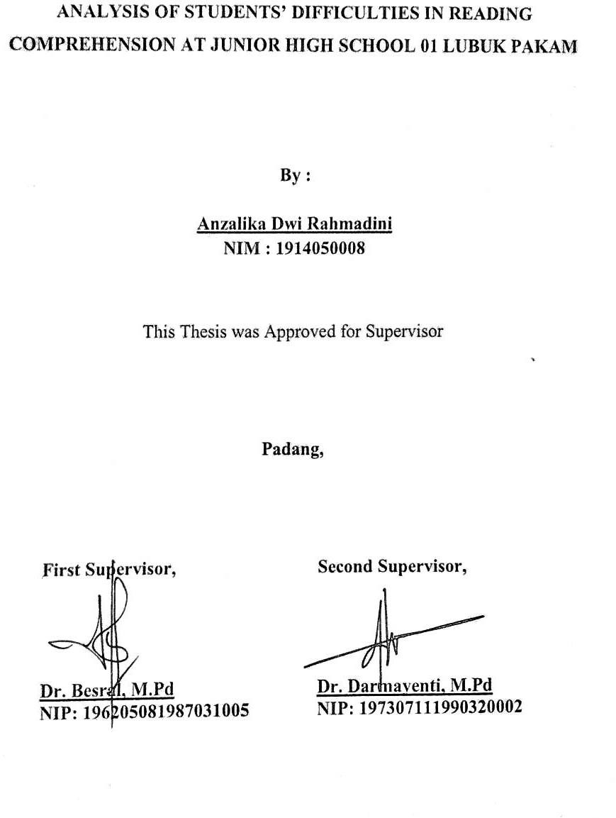

THESIS ACCEPTANCE
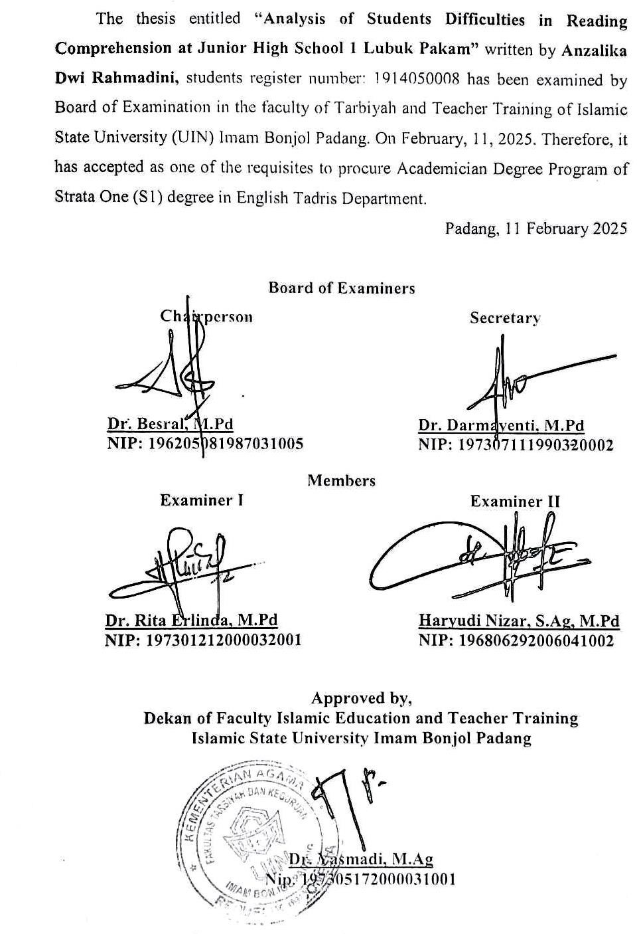

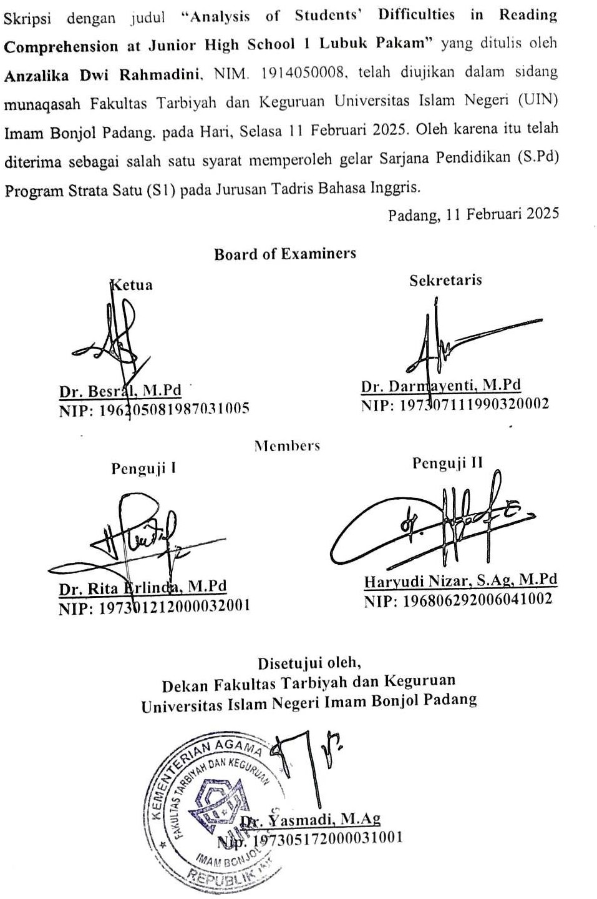

PENGESAHAN TIM PENGUJI

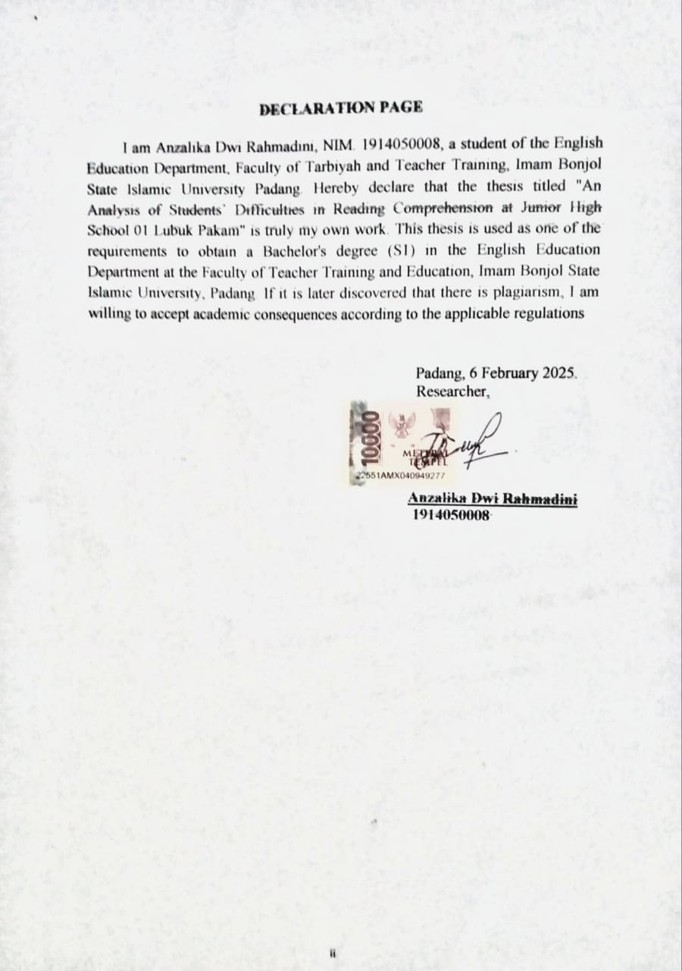

DEDICATION

Alhamdulillahirabbil’alamin, senantiasa rasa puji serta syukur yang mendalam terhadap Allah SWT yang senantiasa memberikan kelancaran, rahmat dan karunianya sehingga terselesaikannya skripsi ini, sekaligus suatu persembahan penulis kepada kedua orang tua beserta adik penulis. Dengan mengucapkan Bismillahirrahmanirrahiim dan rasa syukur, penulis mempersembahkan skripsi ini kepada:
Pertama, Papa yang penulis sayangi, Syafrizal. Pria yang bersedia mendengar setiap keluh kesah anak perempuannya, yang mengusahakan apapun yang beliau bisa demi anak perempuannya tanpa kenal lelah dan sakit. Selalu memberikan motivasi yang mampu mendukung anak perempuannya dalam menyelesaikan skripsi ini.
Kedua, wanita terhebat yang penulis kenal, Mama, ibu Tanti Suryani, yang selalu berdoa untuk anak perempuannya, juga selalu mengerahkan seluruh kemampuannya untuk memenuhi segala kebutuhan penulis, yang selalu memberikan masukan yang bisa menenangkan hati anak perempuannya, yang juga selalu mengharapkan kesuksesan bagi penulis melalui doa-doanya di setiap sujudnya.
Selanjutnya, ketiga saudari perempuan penulis, sang Kakak, Tasya Nafilah Afra, serta kedua Adik penulis, Rizka Elvina Khairani dan Nafiza Sandrina Adinda, yang selalu ada untuk mengibur dan menenangkan di saat penulis sedang mengalami kesulitan, terlebih lagi ingin menyerah.
Keempat, ucapan terimakasih penulis ucapkan kepada diri sendiri karna mampu bertahan dengan segala kesulitan dan rintangan yang ada, sehingga skripsi ini dapat terselesaikan.
Akhir kata, penulis berharap skripsi ini dapat memberi banyak manfaat bagi seluruh pihak yang membutuhkan.

MOTTO
“ The possibility of all those possibilities being possible is just another possibility that can possibly happen.”
(Mark Lee)

Be kind, be humble, be love

ACKNOWLEDGEMENTS
Alhamdulillahirabbil’alamiin. Praise to Allah SWT, who has given the health, opportunity, knowledge and strength to finish this thesis with the title “Analysis of Students’ Difficulties in Reading Comprehension at Junior High School 01 Lubuk Pakam”. Sholawat and salam may be upon our prophet of Muhammad SAW, the beloved Rasul and Prophet of Allah and the leader of Islam, who had struggle for the glory of the only belief on the earth, Islam; May Allah blessed him, and give him peace. The researcher realize that this thesis would not have been completed without the help, advice and guidance from many people. Therefore, in this opportunity, the reasearcher would like to express thanks and gratitude to the following parties for their contribution:
- My appreciation and gratitude to Dr. Besral, M.Pd as my first supervisor and Dr. Darmayenti, M.Pd as my second supervisor.
- My appreciation to Hidayat Al-azmi, M.Pd as the head of the English Tadris Department, and the secretary of English Tadris Department, Dr. Melinda Roza, M.Pd, at Teacher Training Faculty State Islamic University of Imam Bonjol Padang.
- My appreciation to all the lectures who have provided assistance.
- My appreciation to the officer and staffs of the State Islamic University of Imam Bonjol Padang who have helped provide administration.
- My appreciation to the Rector of State Islamic University of Imam Bonjol Padang, Prof. Dr. Martin Kustati, M.Pd.
- My appreciation and deepest gratitude to my beloved parents, Mr. Syafrizal and Mrs. Tanti Suryani, and my beloved sisters Tasya Nafilah, Rizka Elvina and Nafiza Sandrina Adinda. Also thank you to my big family, my beloved grandparents, aunties, uncles and my cousins, for being kind by not saying hurtful comments about my long process, otherwise, they gave me all the support that i needed.
- My biggest thanks to Mrs. Elda Amfitriana, S.Pd, a teacher who was very kind and lovely in my PPL periode.

- My appreciation and gratitude to my friends, Mutiara Suci Kesuma Lbs, Awalia Santika Amanda, Rabiahtuddinil Adawiyah Hrp, Khairunnisa Alamsyah, Ratna Dwi Prawesti, who always listen to my complaints, who helped and comforted me while working on this thesis. Also thankful to people that close to me. The last, thank you to all my classmate of TBI-A’19, thank you very much for the experience, knowledge, and extraordinary moment in my life.
- Last but not least, i wanna thank me, for believing in me, i wanna thank me for doing all this hard work, i wanna thank me for having no days off, i wanna thank me for never quitting and never give up eventhough i ever have that thought once, i wanna thank me for always being a giver and trying to give more than i received, i wanna thank me for trying to do more right than wrong, i wanna thank me for just being me at all times.

Padang, February 2025 Researcher

Anzalika Dwi Rahmadini 1914050008

ABSTRACT

Anzalika Dwi Rahmadini, 2025 : Analysis of Students’ Difficulties in
Reading Comprehension at Junior High School 01 Lubuk Pakam

This study aims to analyse students’ difficulties in Reading Comprehension, especially in terms of indicator that are mostly difficult and the factors causing the difficulties faced by the students at eight grade. This study used a mixed-method design, so the data analysis technique was separated into two parts: quantitative and qualitative. Reading test used for collecting the quantitative data, then questionnaire and interview used for collecting qualitative data. One hundred and fifty students from eight grade in SMPN 1 Lubuk Pakam were participated in Reading Test. Ninety students with the low score were participated in answering questionnaire, and two of the English teachers contributed to the interview. The result from the test showed that the difficulties in identifying main idea was the highest percentage (58%). Then, finding topic and word reference (57%). Understanding vocabulary and identifying detail information (56%). Followed by making inference (54%). From the questionnaire and interview, it was found that five factors causing students’ difficulties in reading comprehension, such as: lack of vocabulary knowledge, fluency, interest and motivation, problems with processing information, and factor from the environment. From this study, it can be concluded that the most difficult indicator in Reading Comprehension was identifying the main idea. This research suggest the Teachers to do some creative technique in teaching english so the students could be more interest in learning English especially ain Reading Comprehension. The researcher also suggests the future researcher do more detailed research further about this study.
Keywords: Reading, Reading Comprehension, students’ difficulties

ABSTRAK

Anzalika Dwi Rahmadini, 2025: Menganalisis Kesulitan Siswa dalam
Pemahaman Membaca bagi Siswa di SMPN 1 Lubuk Pakam

Studi ini bertujuan untuk menganalisis kesulitan siswa dalam Pemahaman Bacaan, terutama dalam hal indikator yang paling sulit dan faktor-faktor yang menyebabkan kesulitan yang dihadapi oleh siswa kelas delapan. Studi ini menggunakan desain metode campuran, sehingga teknik analisis data dibagi menjadi dua bagian: kuantitatif dan kualitatif. Tes membaca digunakan untuk mengumpulkan data kuantitatif, kemudian kuesioner dan wawancara digunakan untuk mengumpulkan data kualitatif. Seratus lima puluh siswa dari kelas delapan di SMPN 1 Lubuk Pakam berpartisipasi dalam Tes Membaca. Sembilan puluh siswa dengan skor rendah berpartisipasi dalam menjawab kuesioner, dan dua guru bahasa Inggris berkontribusi dalam wawancara. Hasil dari tes menunjukkan bahwa kesulitan dalam mengidentifikasi ide utama memiliki persentase tertinggi (58%). Kemudian, menemukan topik dan referensi kata (57%). Memahami kosakata dan mengidentifikasi informasi detail (56%). Diikuti dengan membuat inferensi (54%). Dari kuesioner dan wawancara, ditemukan bahwa ada lima faktor yang menyebabkan kesulitan siswa dalam pemahaman bacaan, yaitu: kurangnya pengetahuan kosakata, kelancaran, minat dan motivasi, masalah dalam memproses informasi, dan faktor dari lingkungan. Dari penelitian ini, dapat disimpulkan bahwa indikator yang paling sulit dalam Pemahaman Bacaan adalah mengidentifikasi ide pokok. Penelitian ini menyarankan kepada para guru untuk menggunakan beberapa teknik kreat if dalam mengajar bahasa Inggris agar siswa lebih tertarik dalam belajar bahasa Inggris, terutama dalam Pemahaman Bacaan. Peneliti juga menyarankan peneliti masa depan untuk melakukan penelitian yang lebih mendetail tentang studi ini.

Kata kunci :Membaca, Pemahaman Membaca, Kesulitan Siswa

TABLE OF CONTENTS

APPROVAL PAGE i
THESIS ACCEPTANCE ii
PENGESAHAN TIM PENGUJI iii
DECLARATION PAGE iv
DEDICATION v
MOTTO vi
ACKNOWLEDGEMENTS vii
ABSTRACT ix
ABSTRAK x
TABLE OF CONTENTS xi
LIST OF TABLES xiii
CHAPTER I INTRODUCTION 1
- Background of the Problem 1
- Identification of the Problem 4
- Limitation of the Problem 5
- Formulation of the Problem 5
- Purpose of the Research 5
- Significances of the Research 5
- Definition of Key Terms 6
CHAPTER II REVIEW OF RELATED LITERATURE 7
- Theoritical Review 7
  - Modern Concept of Reading Comprehension 7
  - Purposes of Reading Comprehension 8
  - Types of Reading Comprehension 9
  - Level of Reading Comprehension 11
  - Components of Reading Comprehension 12
  - Approaches to Reading in Merdeka Curriculum 14
  - Students’ Difficulties in Reading Comprehension 15
  - Elements of genre 18
  - Types of genre 19
- Relevant Studies 23
- Conceptual Framework 26
CHAPTER III RESEARCH METHOD 27
- Research Design 27
- Research Setting 27
- Population and Sample 28
- Research Instrument 29
- Techniques of Data Collection 32
- Technique of Data Analysis 33
CHAPTER IV FINDINGS AND DISCUSSION 35
- Findings 35
  - Most Difficult Components of Reading Comprehension 35
  - Factors Causing Students’ Difficulties in Reading Comprehension 40
- Discussion 51
CHAPTER V CONCLUSION AND SUGGESTION 60
- Conclusion 60
- Suggestion 61
REFERENCES 62
APPENDICES 62

LIST OF TABLES

Table 1.1 Students’ Average Scores in Reading Comprehension 3

Table 3.1 Total population of the students 28

Table 3.2 Blue Print of Reading Comprehension Test 30

Table 3.3 Blue Print of Questionnaire 31

Table 3.4 Blue Print of Interview 31

Table 4.1 Recapitulation of Students’ Answer 36

Table 4.2 Distribution of Students’ Scores in Finding Topic 37

Table 4.3 Distribution of Students’ Scores in Identifying Main Idea 37

Table 4.4 Distribution of Students’ Scores in Reference 38

Table 4.5 Distribution of Students’ Scores in Understanding Vocabulary 38

Table 4.6 Distribution of Students’ Scores in Making Inference 39

Table 4.7 Distribution of Students’ Scores in Identifying Detail Information 39

