CHAPTER I
INTRODUCTION

- Background of Problems
English as an international language that relates so many people in the different countries should be mastered to face globalization era. Therefore, English becomes one of the main subjects that were required by every school to be comprehended by the students. For instance, there are four skills that have to be acquired by the students in English, they are listening, speaking, reading and writing. Among these skills, writing is an important skill to be learned by the students in order to get mastered in learning especially for foreign language learners.
Writing is the most complicated skill that has to be acquired by the learners in English learning, because it requires the writers to involve higher cognitive competence such as the capability to analyze, construct, edit and revise ideas to produce a qualified writing. Therefore, the writing instructors must be able to facilitate the learners with conducive learning that expand their views about certain matters, challenge them with extra rewards and show them the appropriate procedures in developing their writing competence.
Writing competence that involves in the process of analysis and synthesis can be called as whole brained activity that leads everyone to critical thinking. So, writing skill is the most complete activities that have to be acquired by every language learner. Because of this reason, teaching writing, absolutely, must be applied with wholehearted by the classroom practitioners. Teaching writing is not a trivial thing to do. It is not an easy task to make the students competent in producing a qualified writing.
After that, teaching writing has been long focused to the final product of students writing only. Brown (1994) states that “a few decades ago, teachers were mostly concerned with the final product of writing: the essay, the report, the story and what that product should “look like””. This teaching model in the recent era cannot improve and give contribution as an enhancement for the student’s writing quality. Students are framed in an obligation to produce writing in the limited time without make a compromise with the process that they have to deal with. They have to create a product of writing without a chance to re thinking and revise it.
Based on the researcher first observation of the eight grade at Junior High School 36 Sijunjung it was found that the students have some problems dealing with English, especially in writing. The researcher found some problems related with the failure of students in their test. And the problem was related to the students’ writing ability. The difficulties that the students’ face in writing was caused by some factors come from themselves and also from their teacher.
In the students’ side, they did not know the way to start in writing. They did not know what have to be done at the first step like in colleting or generating the ideas. The main factors are students’ knowledge of five components in writing, namely content, organization, vocabulary, language use and mechanic.
Moreover, it was seem very hard for the students in expressing the ideas that come in their mind and bring it into a real form as the beginning of writing process that they have to deal with. All of these problems blocked the students’ mind to attain a good achievement in writing.
The low of student’s writing ability can also be seen from the student's writing sheets when given the writing test as follows:
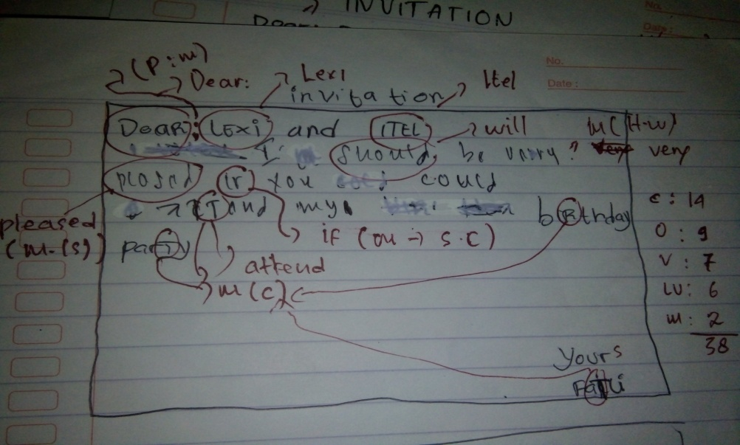
Picture 1.1
The example of student writing test about invitation card

On the picture 1.1 above, the student making text about invitation cards. An invitation card the student should mention: the writer, the invitee, the agenda, and that clear information such as date, day, time, place, and contact person if needed. Based on that picture, the students’ skill in writing is low (mean score of students’ writing test is 38). The students are very poor as reflected on the components of writing such as content (14), organization (9), vocabulary (7) language use (6) and mechanics (2).
The low writing ability of the students would have been an effect on the students' learning achievement. This can be seen from the score of Students MID Test Score of Junior High School 36 Sijunjung Class VIII Year 2017/2018 on the table below:
Table 1.1
Students MID Test Score of
Junior High School 36 Sijunjung Class VIII Year 2017/2018

No | Grade | Total Students | Mean Score | KKM
1 | VIII 1 | 20 | 70.35 | 80
2 | VIII 2 | 21 | 71.76
 | Total | 41 | 71.07
Source : English Teacher’s Book Mark Eight Grade of JHS 36 Sijunjung (See Appendix 2)

From table 1.1 above showed that, the mean score of students’ MID test of the eight grade was still many who have not reached the Minimum Criteria of Mastery Learning (KKM). Based on the information from the English teacher of Junior High School 36 Sijunjung, the Minimum Criteria of Mastery Learning (KKM) assigned for class VIII is 80. So it also shows that students' writing ability at grade eight is still low.
As a problem solving, teacher should to find the other ways to improve student’s ability in creating an acceptable writing. For instance, strategy, technique, method or approach in teaching process should be changed to more creative one.
Brainstorming is one of the techniques that could be used by the teacher in teaching writing. Brainstorming is the process of writing as many thought as the writer has as quickly as she or he can. It is a beneficial technique for writing instruction where the students would be assisted in generating the ideas them appropriately. Brainstorming is a great way to gather the information and generate the ideas about a topic. In Brainstorming session, students offer as many ideas about a particular topic as they can think of, as quickly as they can. The ideas in the brainstorming session are not discussed, they are just listed. Therefore, the through brainstorming in the writing process will promote openness and creativity and the students can generate a lot of thoughts in short time.
Based on that, the researcher was interested in solving the problem of students’ writing ability. So, the researcher conducts a research on “The Effectiveness of Brainstorming Technique to Improve Students’ Writing Ability of The Eight Grade at Junior High School 36 Sijunjung”.

- Identification of Problems
It was necessary to do the planning step well because it will determine the quality of students’ writing product then and very urgent in doing the next stages of writing. But, most of students find the problem in generating the ideas of this writing drafting. This phenomenon suggested that the teacher should try to implement a new approach and technique to reveal the problems. Every learner must realize that writing is not as difficult as they think. Teachers should give them an encouragement that they are capable to accomplish a good writing, exactly. For instance, teaching writing must be applied as interactive and communicative as possible. The teacher has to show the students that writing is interesting and enjoyable. Therefore, the researcher wants to research about brainstorming technique that can be implemented in teaching writing and identify how it influences the students’ writing ability.

- Limitation of Problem
In learning writing, actually the students faced various problems. As mention in identification of the problem above, most of students have difficulties in generating their ideas. It was caused by the student’s lacks in starting their writing process. They did not know to plan their writing in a good way. In addition, the student’s thought have blocked because the writing class was conducted by the teacher could not encourage them to improve their ability in writing. So, the teacher needs to apply an appropriate technique in assisting the students to solve their problems in writing.
Therefore, the researcher limits the problem of this research only about The Effectiveness of Brainstorming Technique to Improve Students’ Writing Ability of The Eight Grade at Junior High School 36 Sijunjung.

- Formulation of Problem
Based on background and limitation of the problem above, the researcher formulated the problem of this research as follows:
- Does brainstorming technique give significant effect on students’ writing ability?
- Does brainstorming technique give positive influence in generating ideas? (content).

- Purpose of the Research
Considering the background and formulation, this study aimed to achieve the following objectives:
- To find out whether brainstorming technique gives significant effect on students’ writing ability.
- To find out brainstorming technique gives positive influence in generating ideas.
- Significance of the Research
This research was expected to give a contribution to teachers, students, further researchers. Sometimes, the writing class become a bored class because its difficulties. In many times, the students feel confused when their teacher asked them to write. Moreover, the students become dislike to write because most often when the teacher revises or corrects their writing work, the teacher only criticizes for the mistake. Unfortunately, this condition most causes the students feel discouraged to write.
For teachers, the teachers should consider about the through brainstorming in teaching writing as an alternative technique that is expected to be able to help the teacher in teaching writing. Beside that, To give some contributions to the students in order to improve students’ ability in writing.
And the students are also expected to enjoy the writing class because their burden would be reduced with following the enjoyable technique to produce a more qualified writing. Through this research, the students are hoped to be more interested in following their writing class. For the other researchers, this research was expected to be used as an additional source especially for those who conduct a research on the students’ writing skill, this research can be used as the reference in making the interesting teaching materials by using brainstorming technique.

- Definition of the Key Terms
In avoiding misinterpretation in this study, the researcher tries to explain some terms that are used in this research:
Brainstorming :is a technique used to generate a long list of diverse responses without making judgments about individual ideas.
Technique :a particular or special way of doing something.
Effect :The result of an influence.
Writing ability :is the activity of writing, in contrast to reading, speaking, etc.
The definition of the whole title, “The Effectiveness of Brainstorming Technique to Improve Students’ Writing Ability of The Eight Grade at Junior High School 36 Sijunjung.

