THE EFFECTIVENESS OF BRAINSTORMING TECHNIQUE TO IMPROVE STUDENTS’ WRITING ABILITY OF THE EIGHT GRADE AT JUNIOR HIGH SCHOOL 36 SIJUNJUNG

THESIS

Submitted in partial Fulfilment as one of the Requirements for
Strata One (SI) Degree

UIN IMAM BONJOL
PADANG

By:

Fitri Nengsih
1314050367

DEPARTMENT OF ENGLISH TADRIS
FACULTY OF ISLAMIC EDUCATION AND TEACHER TRAINING
STATE ISLAMIC UNIVESITY (UIN)
IMAM BONJOL PADANG
1439 H/2018 M

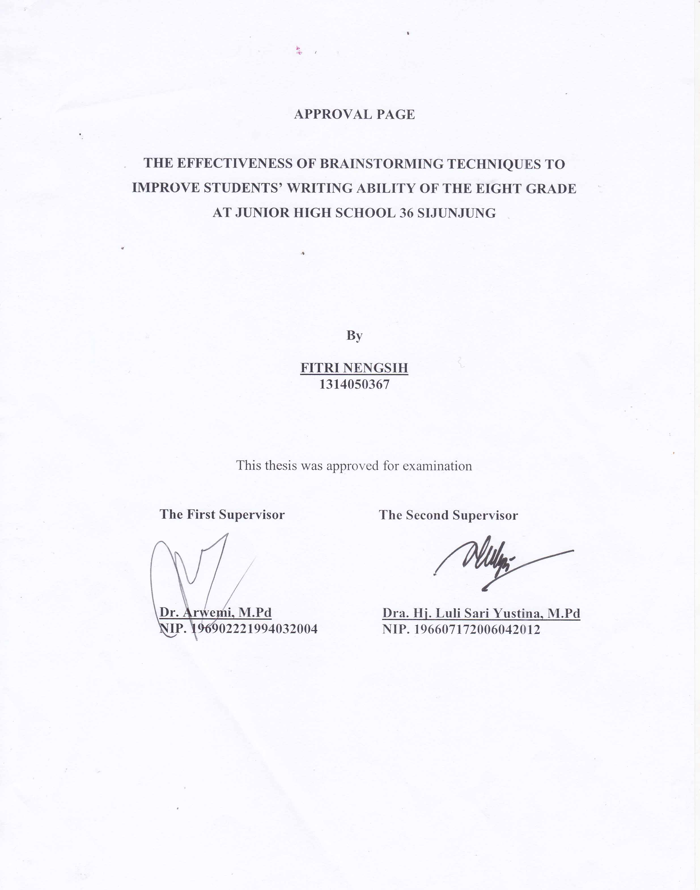

ABSTRACT

Fitri Nengsih, 2018. The effectiveness of Brainstorming Technique to Improve Students’ Writing Ability of the Eight Grade at Junior High School 36 Sijunjung

This study was based on the phenomenon that students of the eight grade at Junior High School 36 Sijunjung had some problems in writing. They did not know the way to start in writing. They did not know what have to be done at the first step like in colleting or generating the ideas.
The researcher tries to investigate the effect of brainstorming technique in improving students’ writing ability, especially in generating the ideas in the process of writing. Brainstorming was assumed as a beneficial technique in developing students’ competence in generating the ideas (content) in learning writing. This research was aimed to see the effect of brainstorming technique on students’ writing ability of the eight grade at Junior High School 36 Sijunjung.
Population of this research was the students of the eight grade at Junior High School 36 Sijunjung. Total numbers of the students are 41 consisted of two classes. Total sampling was used in taking the sample. In this case, all of class VIII was chosen as the experimental class. At the first of the meeting, pretest was given to see the ability of the students in writing (descriptive text) before giving the treatments. Then, the students were taught by using brainstorming technique in writing instruction about four meetings. Finally, posttest was conducted to know the effect of Brainstorming technique to students’writing ability.
This research showed that in post-test mean score (81.60) was higher than mean scores of pre-test (58.48). Aspects of writing components that improved significantly were content, got the higher improvement than other component. From the calculation of the result of the test, it was indicated that t_{calculate} was 37.16 and t_{table} was 1.68 with p = 0,05 and degree of freedom 40. So, it means that t_{calculate} was bigger than t_{table} (37.16,>1.68). It meant that the hypothesis was accepted.
Based on the analysis of the data above, it is concluded that there was a significant difference between pre-test and post-test. Statistically, it was showed that teaching writing by using brainstorming technique improved students’ writing ability of the eight grade at Junior High School 36 Sijunjung. So, it is sugested that the English teacher should consider brainstorming technique in teaching writing with appropriate way and material to achieve the better result.

ABSTRAK

Fitri Nengsih, 2018. The effectiveness of Brainstorming Technique to Improve Students’ Writing Ability of the Eight Grade at Junior High School 36 Sijunjung

Penelitian ini didasari oleh fenomena bahwa siswa-siswa di kelas VIII SMPN 36 Sijunjung mempunyai beberapa masalah dalam menulis. Mereka tidak tahu bagaimana cara menulis. Mereka tidak tahu apa yang harus dilakukan pada langkah pertama dalam menulis seperti dalam mengumpul atau menghasilkan ide.
Penelitian ini mencoba untuk meneliti tentang pengaruh teknik brainstorming dalam meningkatkan kemampuan siswa dalam menulis, khususnya dalam menghasilkan ide-ide dalam bentuk tulisan. Brainstorming diasumsikan sebagai salah satu teknik yang dapat mengembangkan kemampuan siswa dalam menghasilkan ide-ide (isi) dalam menulis. Penerapan teknik ini dapat membuat penulis mengerti seberapa banyak yang dia ketahui tentang topik yang akan ditulis. Penelitian ini bertujuan untuk melihat pengaruh penggunaan teknik brainstorming dalam meningkatkan kemampuan menulis siswa kelas VIII SMPN 36 Sijunjung.
Populasi dari penelitian ini adalah semua siswa kelas VIII SMPN 36 Sijunjung yang terdiri dari 41 siswa yang dibagi ke dalam dua kelas. Pengambilan sample dilakukan dengan teknik total sampling. Dalam hal ini, semua siswa kelas VIII terpilih sebagai kelas eksperimen. Pada pertemuan awal, pretest diberikan untuk melihat kemampuan awal siswa dalam menulis (teks deskriptif). Setelah itu, siswa diajarkan dengan menggunakan teknik brainstorming selama empat kali pertemuan. Selanjutnya, posttest diberikan untuk melihat pengaruh penggunaan teknik brainstorming dalam meningkatkan kemampuan menulis siswa.
Penelitian ini menunjukkan bahwa dalam post-test peneliti menemukan bahwa nilai rata-rata (81.60) lebih tinggi daripada nilai pre-test 58.48). Komponen menulis yang meningkat secara signifikan adalah isi, karena memiliki perubahan yang tinggi dibandingkan aspek menulis lainnya. Dari hasil pengolahan data tersebut diperoleh bahwa t-_{hitung} adalah 31,16 dan t-_{tabel} 1.68 dengan p = 0,05 dan derajat kebebasan 40. Itu berarti bahwa t- _{hitung} lebih besar dari t- _{tabel}. (37.16,>1.68). Itu berarti hipotesis diterima dan penelitian berhasil.
Berdasarkan hasil analisis data di atas dapat disimpulkan bahwa ada perbedaan yang signifikan antara nilai prêt test dengan post test. Secara statistik, hal itu menunjukkan bahwa mengajar menulis dengan menggunakan teknik brainstorming meningkatkan kemampuan menulis siswa kelas VIII SMPN 36 Sijunjung. Jadi, disarankan kepada guru bahasa inggris untuk menggunakan teknik brainstoming dengan cara yang tepat dan materi yang tepat untuk mencapai hasil yang lebih baik.

ACKNOWLEDGEMENT
“In the Name of Allah, the Most Gracious, the Most Merciful”
“Alhamdulillahirabbil’alamin”. Praise to be Allah SWT who has given the opportunity, health, knowledge, and strength to finish this thesis. The researcher also expresses her deep praises to the prophet Muhammad SAW and would like to send “Sholawat” and “Salam” to him, “the Uswatun Hasanah” for all Moeslems.
The title of this thesis is “The Effectiveness of Brainstorming Technique to Improve Students’ Writing Ability of the Eight Grade at Junior High School 36 Sijunjung. This thesis is writen to fulfill one of the requirements to obtain undergraduate degree (S1) from the program study at the English Department in Tarbiyah Faculty of UIN Imam Bonjol Padang.This thesis was impossible to be completed without helps and supports from many people. So that, the researcher would like to express her sincere gratitude and great thanks to the following persons:
- Dr. Arwemi, M.Pd as the first supervisor and Dra. Hj. Luli Sari Yustina, M.Pd, as second supervisor who always contribute intellectual advice to me, and had given helps, guiding, valuable suggestion, command, correction, and times to support me in completing this thesis.
- Besral, S.Pd, M.Pd as a chairman of English Tadris Department who has helped me during my academic year.
- The lecturers of Tadris Department, for giving precius thoughts, knowledge, and motivation which are really useful in facing my future.
- Dekan of Tarbiyah Faculty of UIN Imam Bonjol Padang and all staff members of the faculty for their appreciation and supports.
- Hamdani, S.Pd and Tefri Yadni, S.Pd (Headmaster and English Teacher of Junior High School 36 Sijunjung) for their permission and opportunity to conduct the research.
- The students of Junior High School 36 Sijunjung who have given their time in occupation in doing this research.
- My Beloved Parents (Thamrin and Hasmawati), my beloved sisters (teni, esa and fatma) my lovely nephew (arfa) and my lovely big family who always love, pray, support, and motivate me in finishing my study. You are my reason to keep up the achievement.

At last, The researcher realized that this thesis is not perfect yet and has several weaknesses. Therefore, any comment and suggestion, and criticism are expected to come up from the readers in order to make a great one and this thesis is more useful.
Padang, February 19, 2018 The Researcher,

Fitri Nengsih
1314050367

TABLE OF CONTENT
Page
APPROVAL PAGE
THESIS ACCEPTANCE
ABSTRACT i
ACKNOWLEDGEMENT iii
TABLE OF CONTENT v
LIST OF TABLE vii
LIST OF APPENDICES viii
CHAPTER I INTRODUCTION
- Background of the Problem 1
- Identification of the Problem 5
- Limitation of the Problem 6
- Formulation of the Problem 6
- Purpose of the Research 7
- Significant of the Research 7
- Definition of Key Term 8

CHAPTER II REVIEW OF RELATED LITERATURE
- Brainstorming Technique 10
1. Definition of Branstorming 10
2. The Principle of Brainstorming 11
3. The Procedure of Brainstorming Technique 13
4. Brainstorming Technique in Teaching Writing 14
5. The Advantages of Brainstorming in teaching
writing 15
- Writing 16
- The Nature of Writing 16
- Writing proses 17
- Proses approach in teaching writing 18
- Multiple Stage in Proses Approach of Writing 19
- Teaching Writing Technique 23
- Writing Assesment 29
- Relevant Study 32
- Conceptual Framework 33
- Hypothesis 36
CHAPTER III METHOD OF RESEARCH
- Research Design 37
- Population and Sample 39
  - Population 39
  - Sample 39
- Time and Place 40
- Instrumentation 41
- Procedure of Doing Research 45
- Types of Data 49
- Technique of Data Collection 49
- Technique of Data Analysis 50

CHAPTER IV FINDING AND DISCUSSION
- Research Finding 54
      - Description of Data 54
      - Analysis of the Data 63
- Discussion on Finding 69

CHAPTER V CONCLUSION AND SUGGESTION
- Conclusion 72
- Suggestion 73

REFERENCES
APPENDICES

LIST OF TABLES

TABLE 1.1 Students MID Test Score of JHS 36 Sijunjung 4
TABLE 2.1 Indicator and Criteria of Scoring Writing based on Jacob 30
TABLE 3.1 Reseach Concept 38
TABLE 3.2 Procedure of One Group Pre-test Post-test Design 38
TABLE 3.3 Population of JHS 36 Sijunjung 39
TABLE 3.4 Research Schedule 41
TABLE 3.5 Sample of Instrument in giving writing score 42
TABLE 3.6 Indicator and Criteria of Scoring Writing based on Jacob 43
TABLE 3.7 Treatment Procedure of learning and teaching Writing 47
TABLE 4.1 The Data of Writing Pre test Score 55
TABLE 4.2 Pre test Score Result of experimental Class 57
TABLE 4.3 The mean score of Pre test in Term of C, O, V, LU, M 57
TABLE 4.4 The Interval Students’ Writing Score of Pre-test 58
TABLE 4.5 The Data of Writing Post-test Scores 59
TABLE 4.6 Post-test Result of Experimental Class 60
TABLE 4.7 The Mean Score of Post-test in term C, O, V, Lg.U, M 61
TABLE 4.8 The Interval Students’ Writing Score of Post-test 61
TABLE 4.9 Description of Pre and Post test Scores of Exp Class 62
TABLE 4.10 The Comparison of Pre and Post test Result 63
TABLE 4.11 The Comparison of Mean Score in Term C, O, V, Lg.U, M 66

LIST OF APPENDICES

APPENDIX 1 Picture The example of student writing test about invitation
card 74
APPENDIX 2 Mid Term Test Score of Class VIII JHS 36 Sijunjung 75
APPENDIX 3 Analysis of Normality and Homogenity MidTerm of class
VIII at JHS 36 Sijunjung 79
APPENDIX 4 Blue Print of Writing Test 81
APPENDIX 5 Lesson Plan of Teaching Writing 85
APPENDIX 6 Analysis of Normality and Homogenity Pre-test and
Post-test of Experimental Class 116
APPENDIX 7 Mean Score and Standar Deviation Pre-test and Post-te
of Experimental Class 119
APPENDIX 8 Format Students’ Worksheet Pre-test and Post-test 121
APPENDIX 9 Students’ Worksheet Pre-test and Post-test 123
APPENDIX 10 Documentation 135
T-Table

